**PIZZA SALES REPORT DASHBOARD**

PROBLEM-STATEMENT

**1. KPI’s REQUIREMENT**

We need to analyze key indicators for our pizza sales data to gain insights into our business performance. Specifically, we want to calculate the following metrics:

1. Total Revenue: The sum of the total price of all pizza orders.
2. Average Order Value: The average amount spent per order, calculated by dividing the total revenue by the total number of orders.
3. Total Pizzas Sold: The sum of the quantities of all pizzas sold.
4. Total Orders: The total number of orders placed.
5. Average Pizzas Per Order: The average number of pizzas sold per order, calculated by dividing the total number of pizzas sold by the total number of orders.

**2. CHARTS REQUIREMENT**

We would like to visualize various aspects of our pizza sales data to gain insights and understand key trends. We have identified the following requirements for creating charts:

**1.Hourly Trend for Total Pizzas Sold:**

Create a stacked bar chart that displays the hourly trend of total orders over a specific time period. This chart will help us identify any patterns or fluctuations in order volumes on a hourly basis.

**2.Weekly Trend for Total Orders:**

Create a line chart that illustrates the weekly trend of total orders throughout the year. This chart will allow us to identify peak weeks or periods of high order activity.

**3**.**Percentage of Sales by Pizza Category:**

Create a pie chart that shows the distribution of sales across different pizza categories. This chart will provide insights into the popularity of various pizza categories and their contribution to overall sales.

**4.Percentage of Sales by Pizza Size:**

Generate a pie chart that represents the percentage of sales attributed to different pizza sizes. This chart will help us understand customer preferences for pizza sizes and their impact on sales.

**5.Total Pizzas Sold by Pizza Category:**

Create a funnel chart that presents the total number of pizzas sold for each pizza category. This chart will allow us to compare the sales performance of different pizza categories.

**6.Top 5 Best Sellers by Revenue, Total Quantity and Total Orders**

Create a bar chart highlighting the top 5 best-selling pizzas based on the Revenue, Total Quantity, Total Orders. This chart will help us identify the most popular pizza options.

**7. Bottom 5 Best Sellers by Revenue, Total Quantity and Total Orders**

Create a bar chart showcasing the bottom 5 worst-selling pizzas based on the Revenue, Total Quantity, Total Orders. This chart will enable us to identify underperforming or less popular pizza options.

**SOLUTION**

**1. PIZZA SALES SQL-QUERIES**

**A. KPI’S**

**1. TOTAL REVENUE:**

SELECT SUM(TOTAL_PRICE) AS TOTAL_REVENUE FROM PIZZA_SALES;

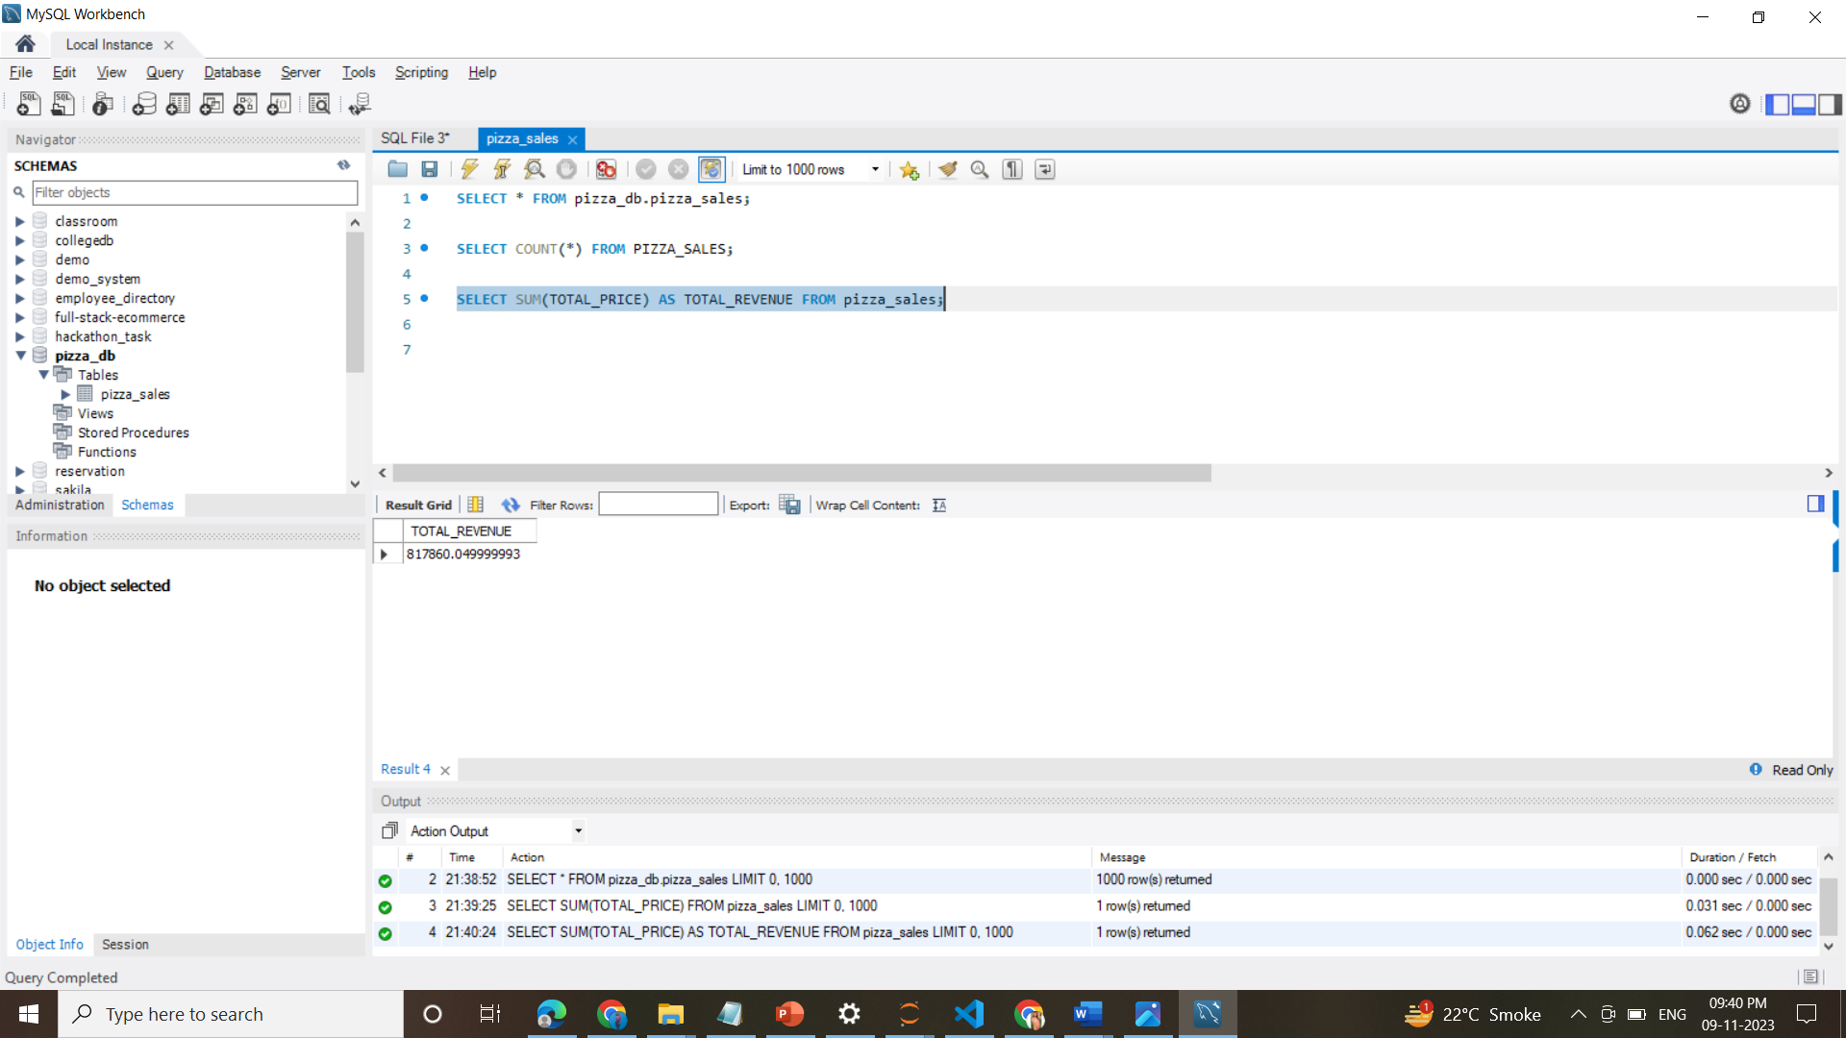

**2. AVERAGE ORDER VALUE**

SELECT (SUM(TOTAL_PRICE) / COUNT(DISTINCT ORDER_ID)) AS AVG_ORDER_VALUE FROM PIZZA_SALES

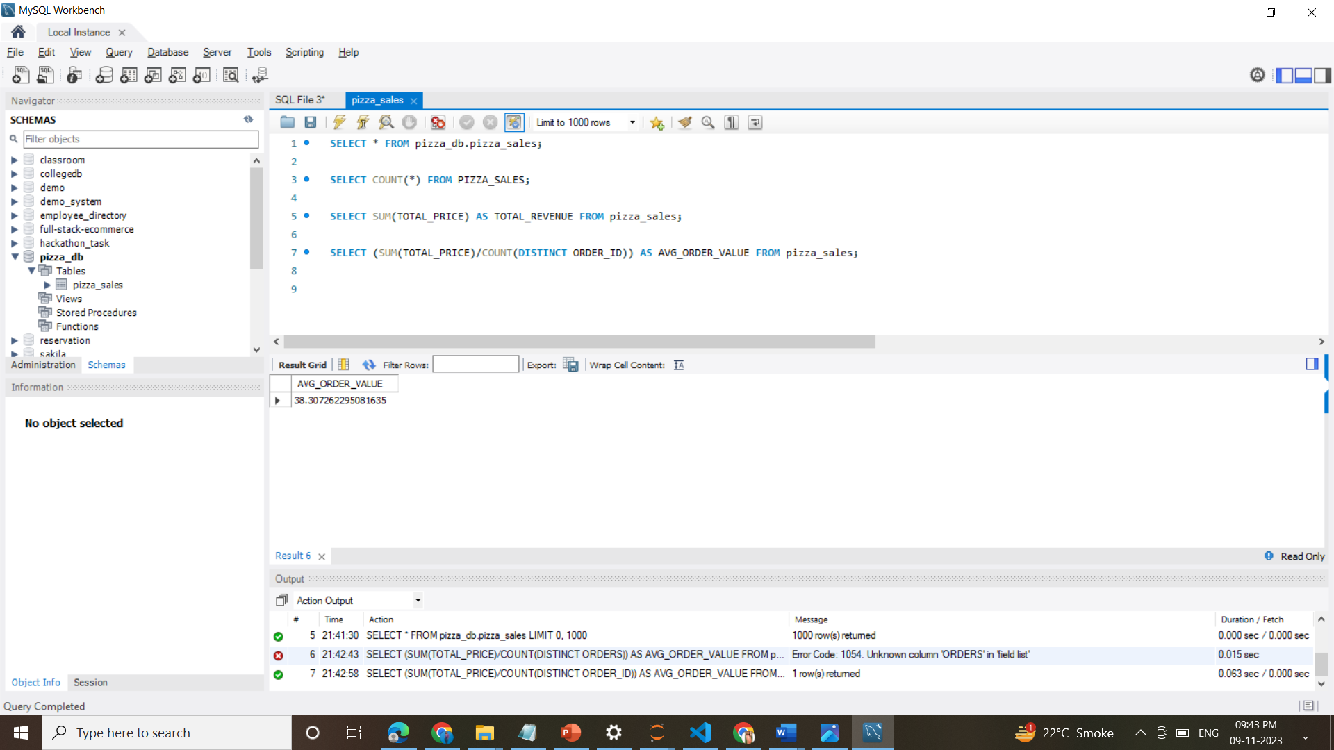

**3. TOTAL PIZZAS SOLD**

SELECT SUM(QUANTITY) AS TOTAL_PIZZA_SOLD FROM PIZZA_SALES

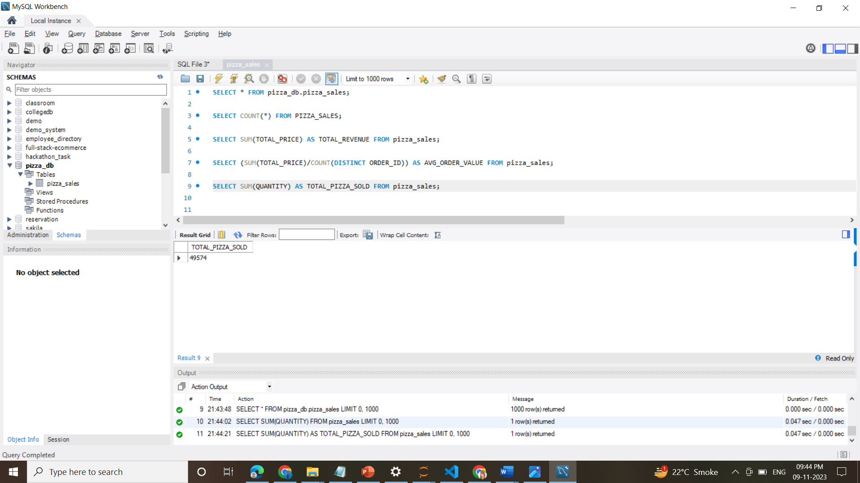

**4. TOTAL ORDERS**

SELECT COUNT(DISTINCT ORDER_ID) AS TOTAL_ORDERS FROM PIZZA_SALES

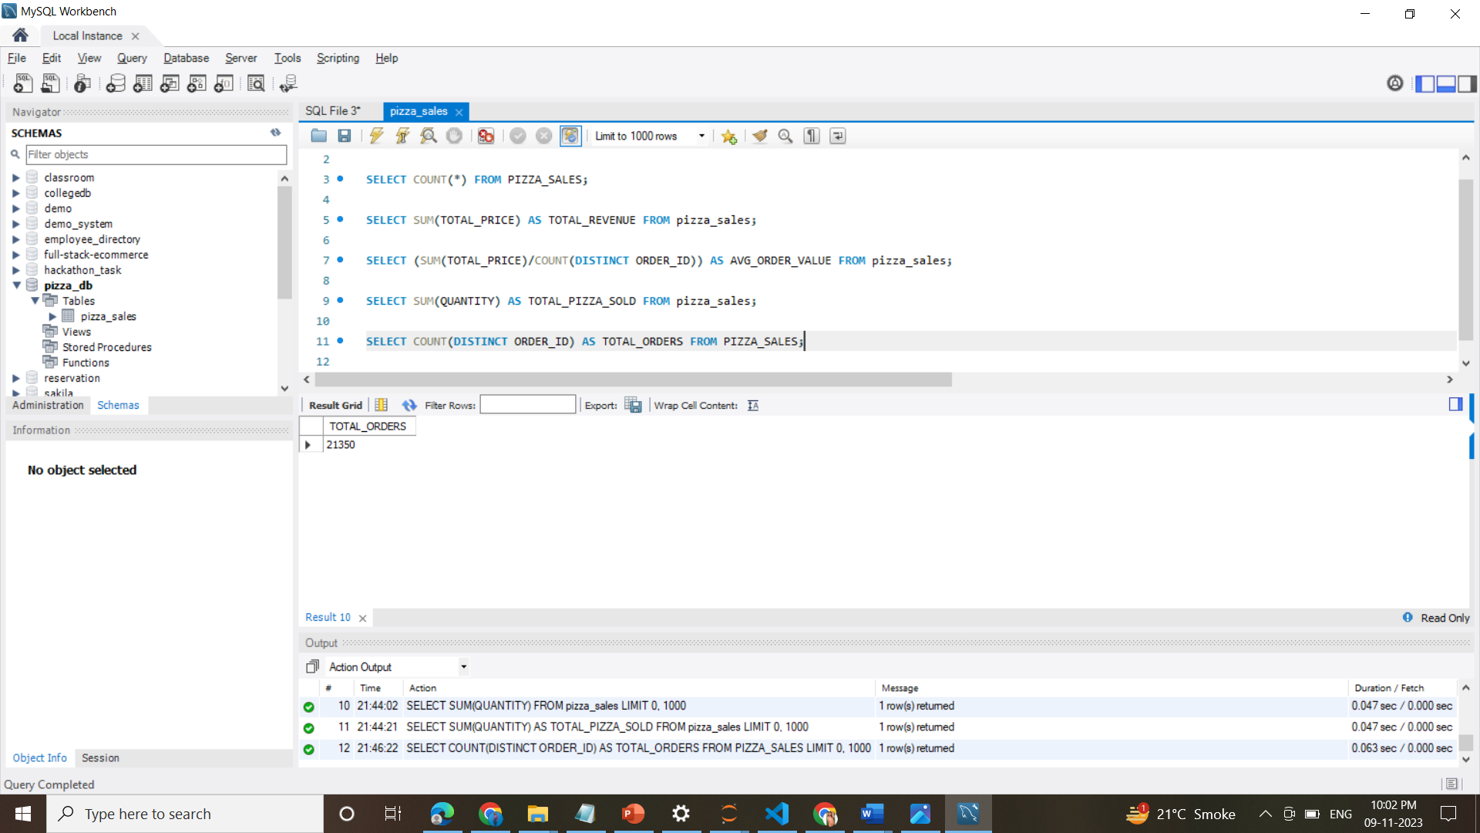

**5. AVERAGE PIZZAS PER ORDER**

SELECT CAST(CAST(SUM(QUANTITY) AS DECIMAL(10,2)) /

CAST(COUNT(DISTINCT ORDER_ID) AS DECIMAL(10,2)) AS DECIMAL(10,2))

AS AVG_PIZZAS_PER_ORDER

FROM PIZZA_SALES

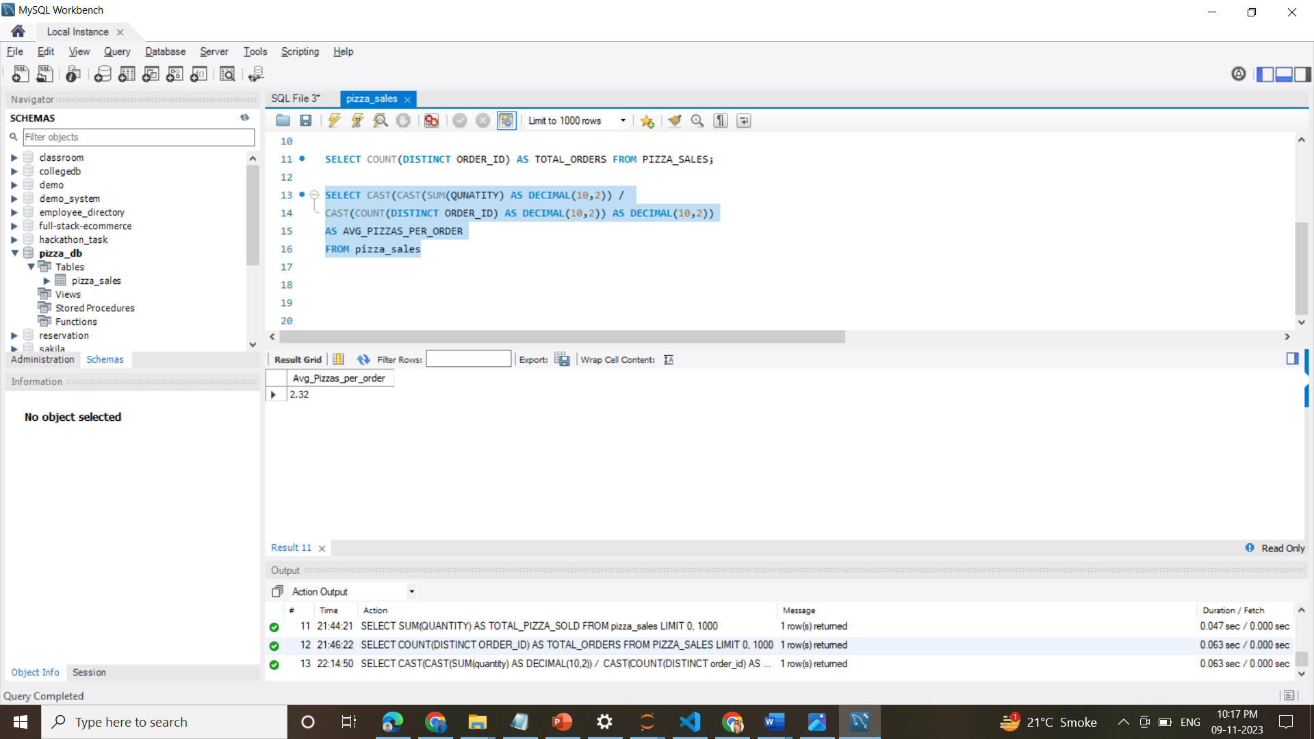

**B. HOURLY TREND FOR TOTAL PIZZAS SOLD**

SELECT HOUR(ORDER_TIME) AS ORDERS_HOURS, SUM(QUANTITY) AS TOTAL_PIZZAS_SOLD

FROM PIZZA_SALES

GROUP BY HOUR(ORDER_TIME)

ORDER BY HOUR(ORDER_TIME);

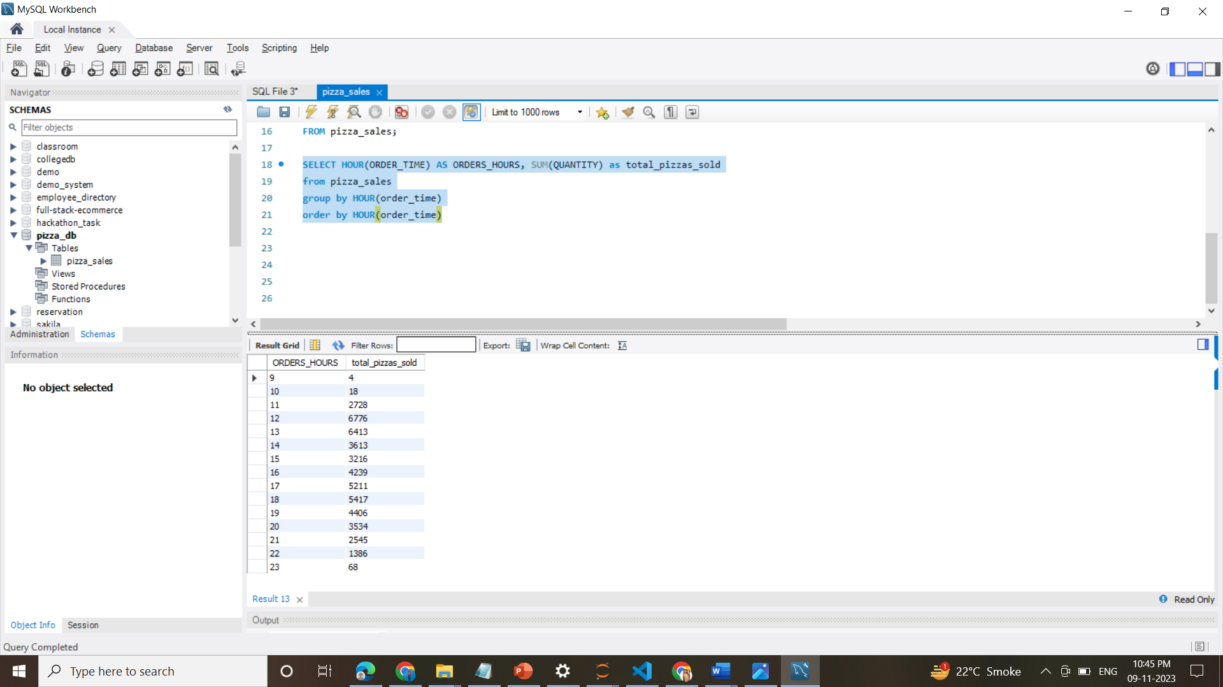

**C. WEEKLY TREND FOR ORDERS**

SELECT

WEEK(ORDER_DATE, 3) AS WEEKNUMBER,

YEAR(ORDER_DATE) AS YEAR,

COUNT(DISTINCT ORDER_ID) AS TOTAL_ORDERS

FROM

PIZZA_SALES

GROUP BY

WEEK(ORDER_DATE, 3),

YEAR(ORDER_DATE)

ORDER BY

YEAR, WEEKNUMBER;

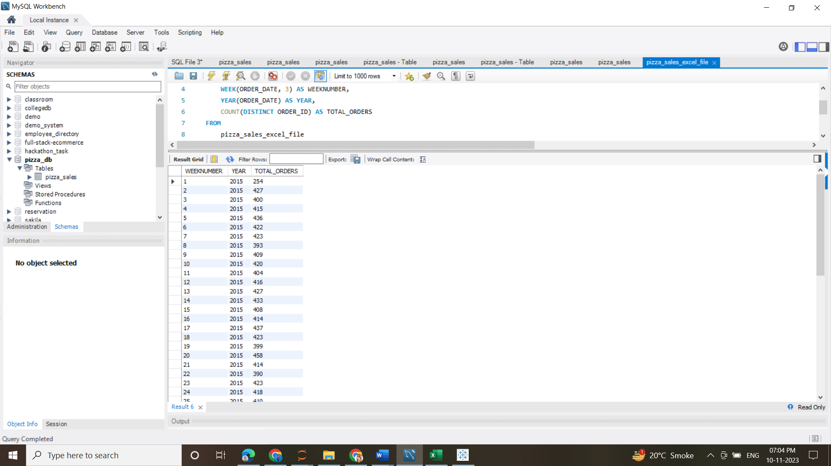 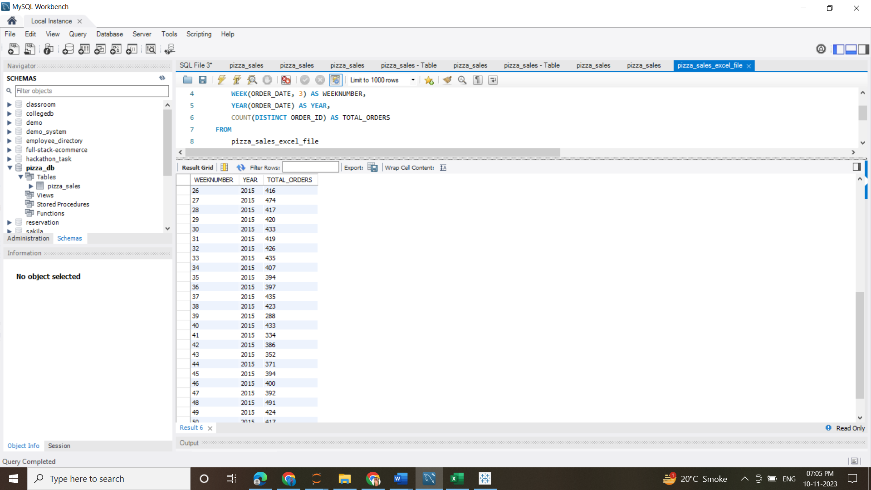 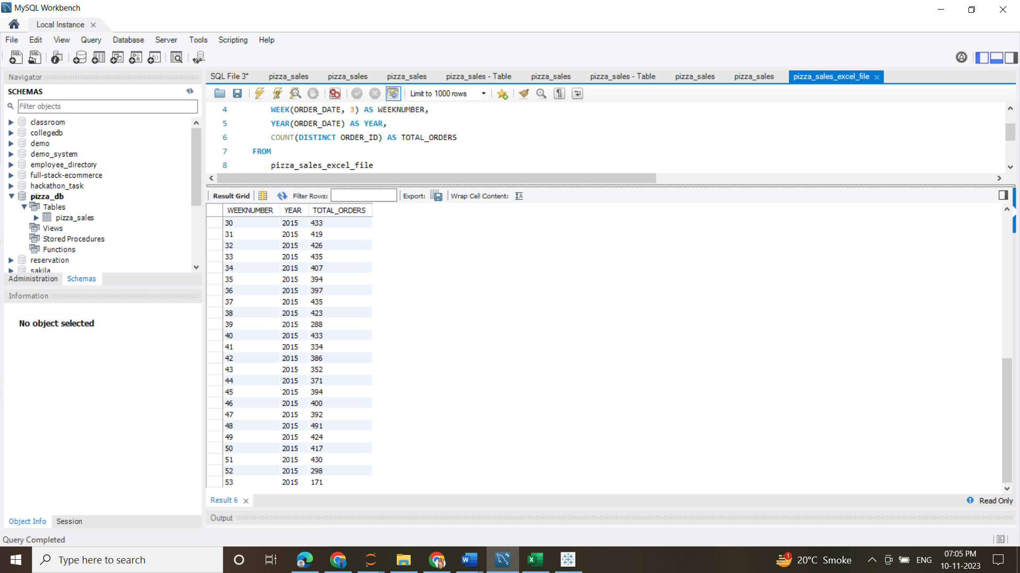

**D. % OF SALES BY PIZZA CATEGORY**

SELECT

PIZZA_CATEGORY,

CAST(SUM(TOTAL_PRICE) AS DECIMAL(10,2)) AS TOTAL_REVENUE,

CAST((SUM(TOTAL_PRICE) * 100) / (SELECT SUM(TOTAL_PRICE) FROM PIZZA_SALES) AS DECIMAL(10,2)) AS PCT

FROM

PIZZA_SALES

GROUP BY

PIZZA_CATEGORY;

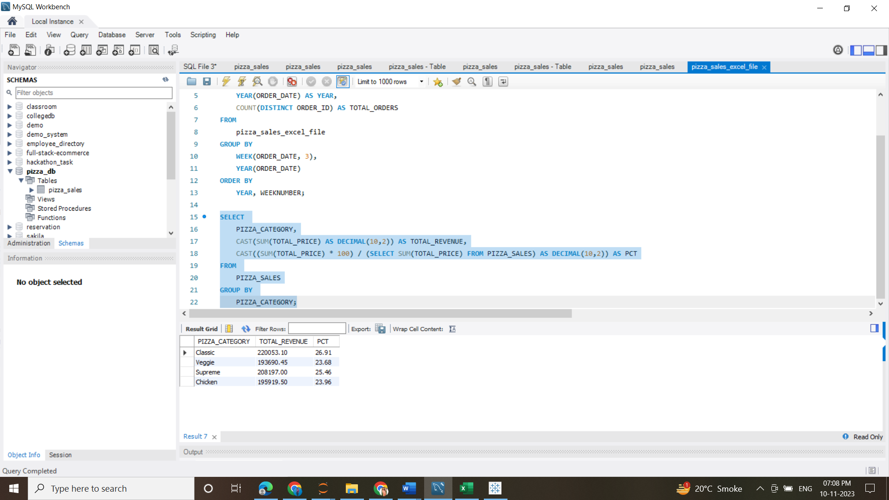

**E. % OF SALES BY PIZZA SIZE**

SELECT PIZZA_SIZE, CAST(SUM(TOTAL_PRICE) AS DECIMAL(10,2)) AS TOTAL_REVENUE,

CAST(SUM(TOTAL_PRICE) * 100 / (SELECT SUM(TOTAL_PRICE) FROM PIZZA_SALES) AS DECIMAL(10,2)) AS PCT

FROM PIZZA_SALES

GROUP BY PIZZA_SIZE

ORDER BY PIZZA_SIZE;

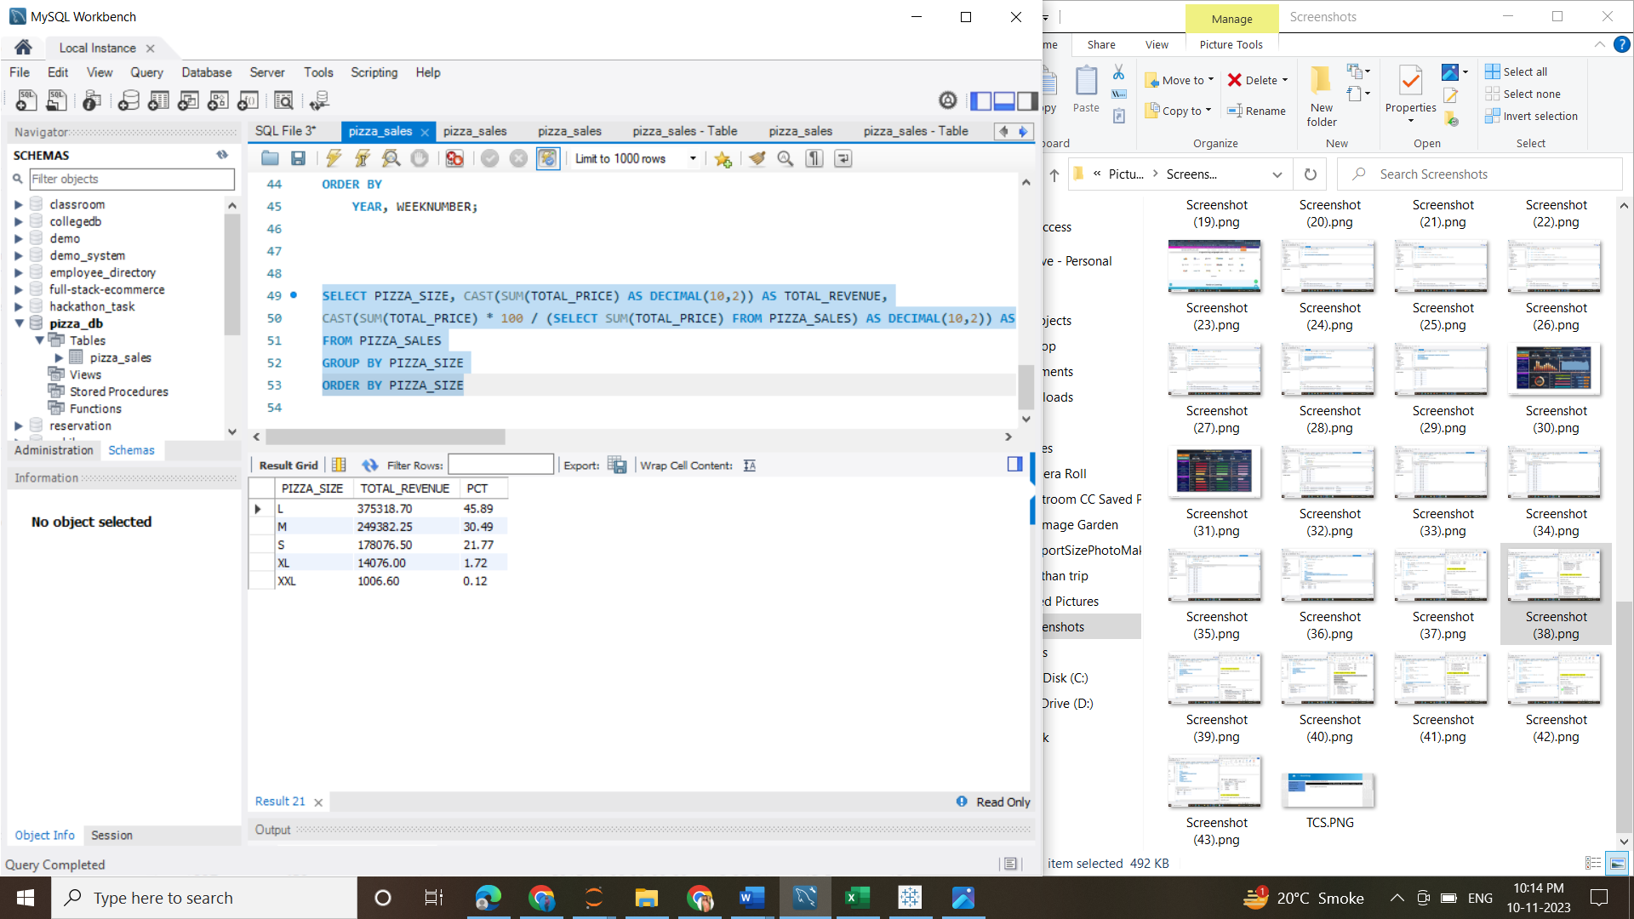

**F. TOTAL PIZZAS SOLD BY PIZZA CATEGORY**

SELECT PIZZA_CATEGORY, SUM(QUANTITY) AS TOTAL_QUANTITY_SOLD

FROM PIZZA_SALES

GROUP BY PIZZA_CATEGORY

ORDER BY TOTAL_QUANTITY_SOLD DESC

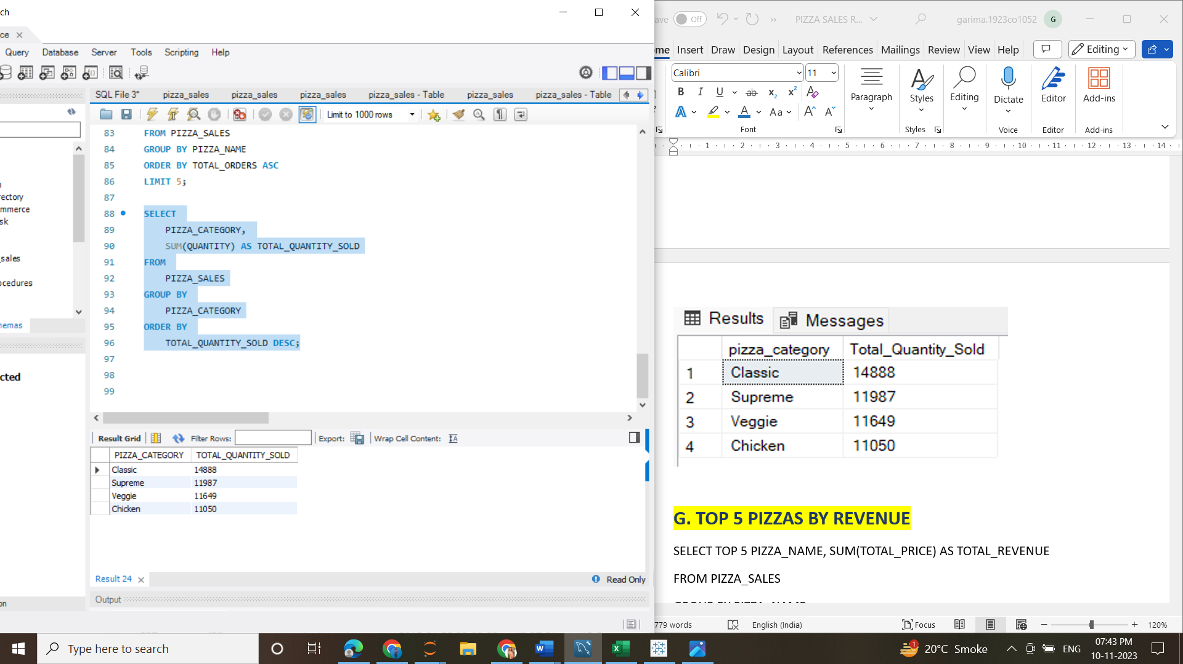

**G. TOP 5 PIZZAS BY REVENUE**

SELECT PIZZA_NAME, SUM(TOTAL_PRICE) AS TOTAL_REVENUE

FROM PIZZA_SALES

GROUP BY PIZZA_NAME

ORDER BY TOTAL_REVENUE DESC

LIMIT 5

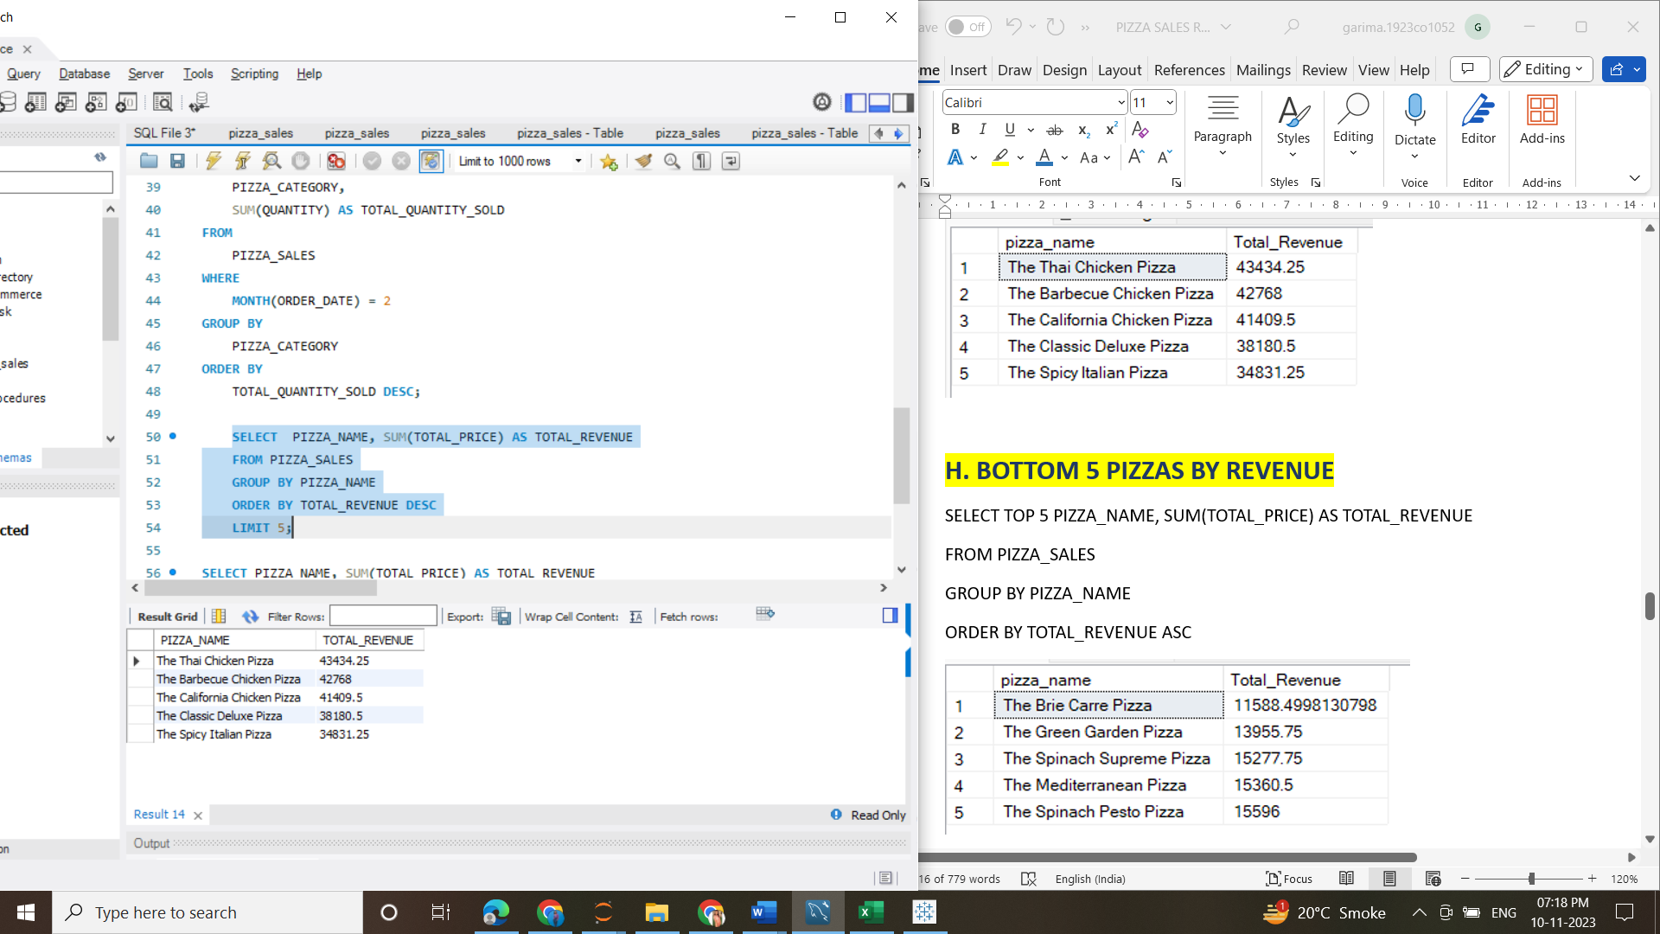

**H. BOTTOM 5 PIZZAS BY REVENUE**

SELECT TOP 5 PIZZA_NAME, SUM(TOTAL_PRICE) AS TOTAL_REVENUE

FROM PIZZA_SALES

GROUP BY PIZZA_NAME

ORDER BY TOTAL_REVENUE ASC

LIMIT 5

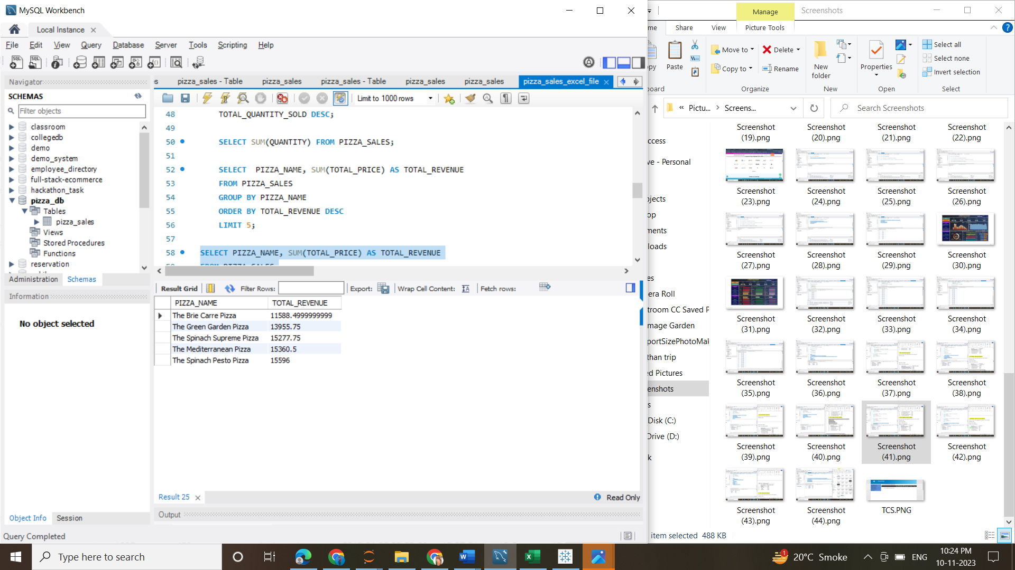

**I. TOP 5 PIZZAS BY QUANTITY**

SELECT PIZZA_NAME, SUM(QUANTITY) AS TOTAL_PIZZA_SOLD

FROM PIZZA_SALES

GROUP BY PIZZA_NAME

ORDER BY TOTAL_PIZZA_SOLD DESC

LIMIT 5

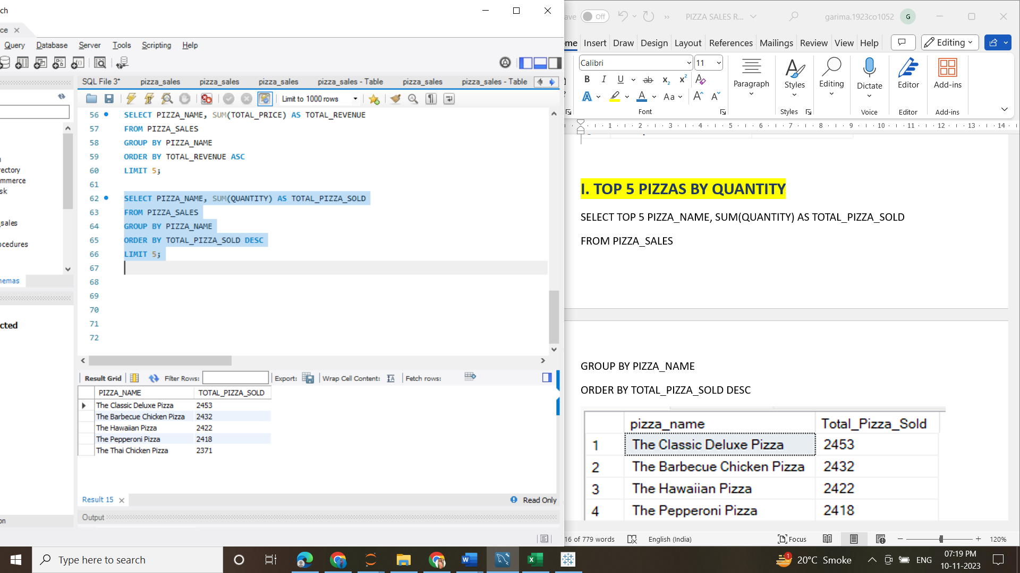

**J. BOTTOM 5 PIZZAS BY QUANTITY**

SELECT PIZZA_NAME, SUM(QUANTITY) AS TOTAL_PIZZA_SOLD

FROM PIZZA_SALES

GROUP BY PIZZA_NAME

ORDER BY TOTAL_PIZZA_SOLD ASC

LIMIT 5

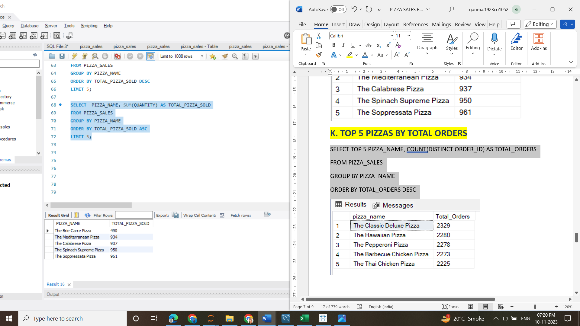

**K. TOP 5 PIZZAS BY TOTAL ORDERS**

SELECT PIZZA_NAME, COUNT(DISTINCT ORDER_ID) AS TOTAL_ORDERS

FROM PIZZA_SALES

GROUP BY PIZZA_NAME

ORDER BY TOTAL_ORDERS DESC

LIMIT 5

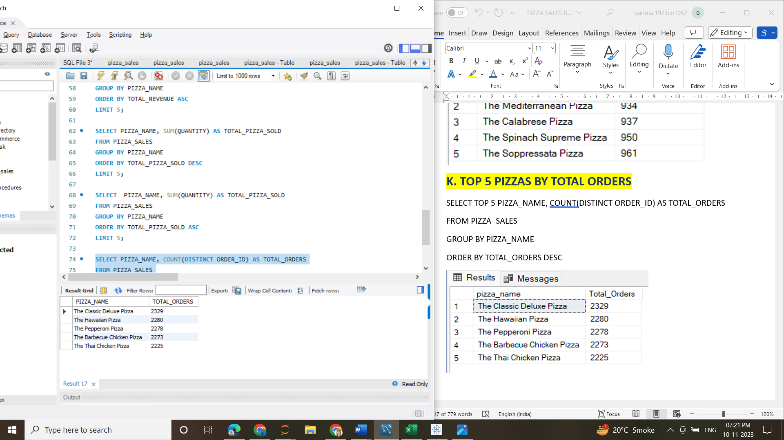

**L. BOTTOM 5 PIZZAS BY TOTAL ORDERS**

SELECT PIZZA_NAME, COUNT(DISTINCT ORDER_ID) AS TOTAL_ORDERS

FROM PIZZA_SALES

GROUP BY PIZZA_NAME

ORDER BY TOTAL_ORDERS ASC

LIMIT 5

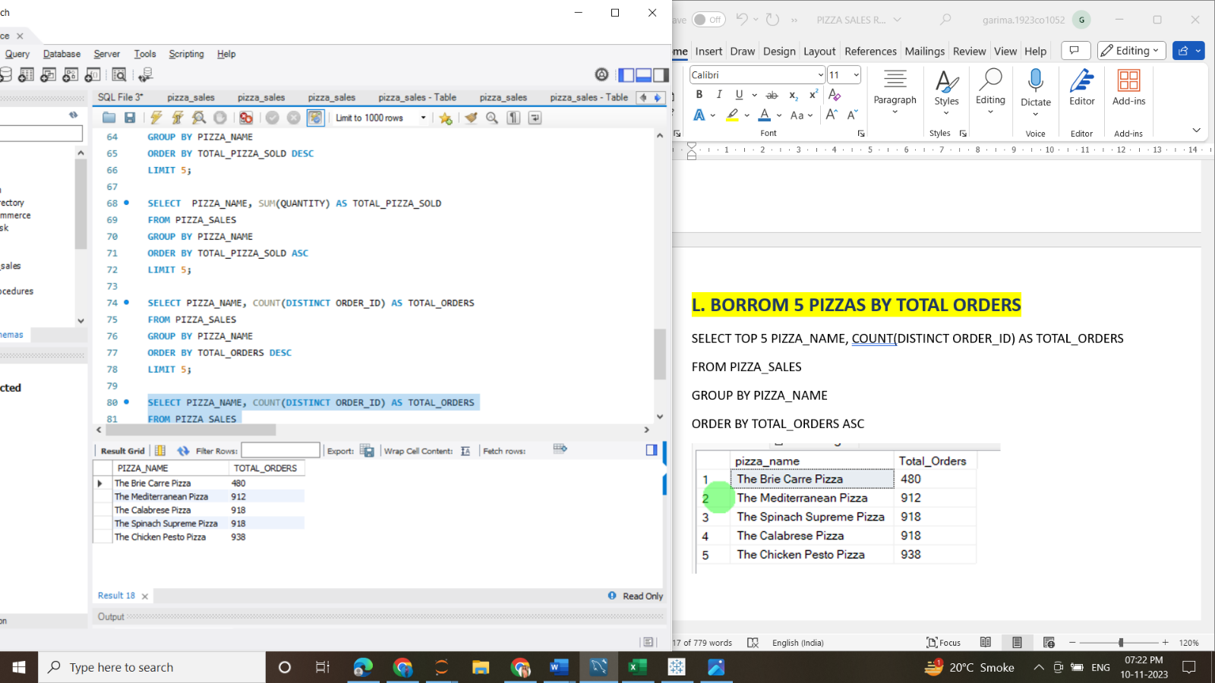

**2. TABLEAU DASHBOARD**

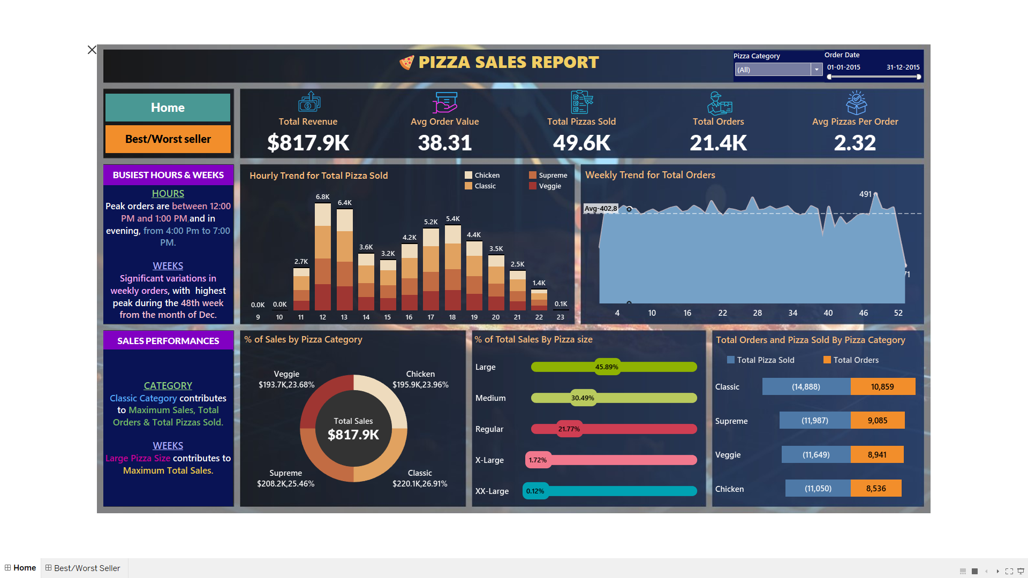

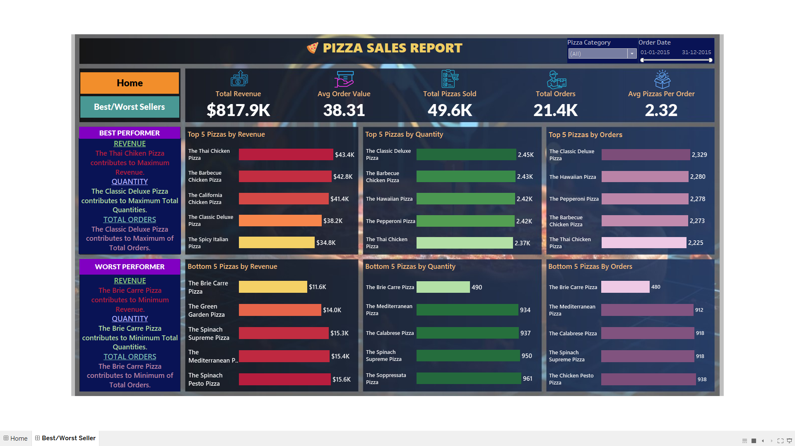

Dashboard-link - [tableau.com/garima.kushwaha/viz/PizzaSalesReportDashboard](https://public.tableau.com/app/profile/garima.kushwaha/viz/PizzaSalesReportDashboard_16993455492640/Home)

Software Used – MYSQL & TABLEAU